Week #2: Urbanized-Rail Innovation
Rail innovation in the U.S. changed many aspects of development in the country. The completion of the U.S. Transcontinental Railroad in 1869 was a major milestone in increasing connectivity and movement of people. With the completion of this railroad, people were able to move faster and easier. The journey that the rail could take reduced the struggles for traveling in many ways. For example, the journey that could take with the stagecoach bus was significantly reduced as the rail could complete the same journey in a few hours. Both people and goods could move across the country freely, faster, and cheaply. A good example is the case of the U.S. Transcontinental Railroad, which was completed in 1869. The railroad cut the journey that took people about six months to just six days. The railroad also connected cities and influenced the upcoming of major economic centers along the way.
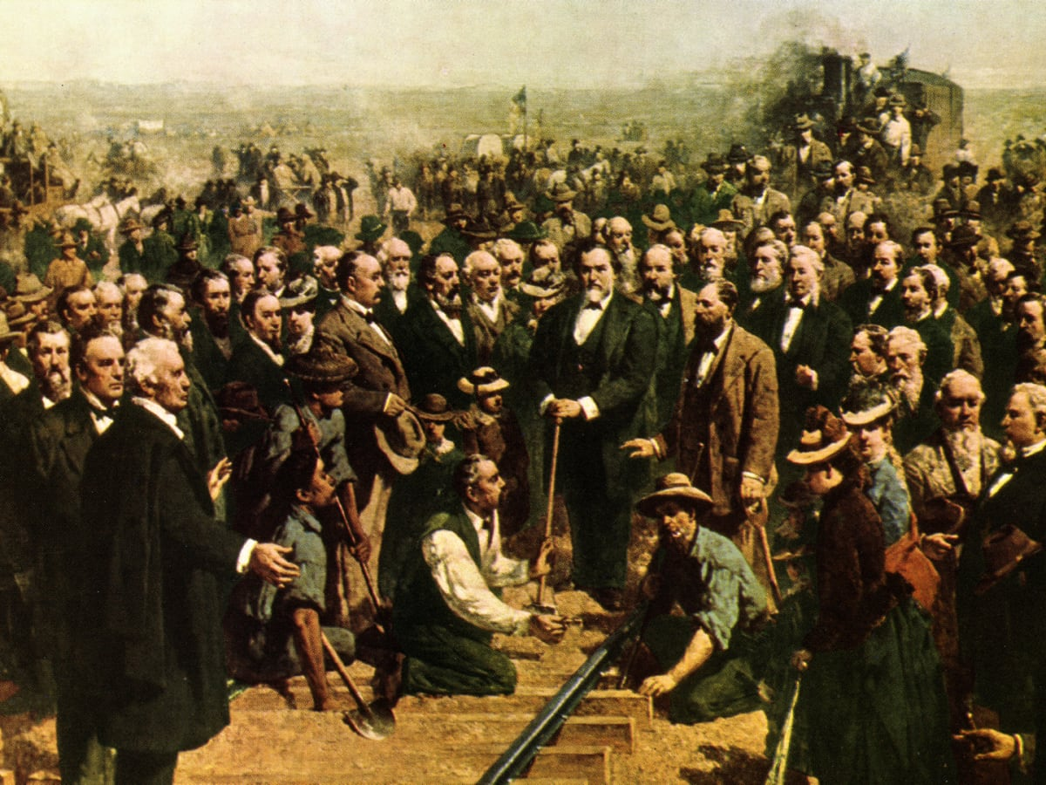
U.S. Transcontinental Railroad Construction
Week#3: Modernist and Traditionalist-Contributions of Walter Gropius
Some of the early architects in American history include Walter Gropius who introduced the concept of conserving and utilization of open space by using the smallest space to maximize the output. Walter is known for his concept that all housing should take the high-rise towers design in order to minimize the utilization or wastage of the open-space. The idea that Walter brought in1922 has remained to be the modern way of construction as most buildings seem to take the concept. Most buildings, especially in the urban areas, where land utilization is becoming critical, are constructed using the high-rise tower design. This design has ensured that people can build more units within a small portion of land. A piece of land of about 1/8 acres that could only accommodate construction of a few units, can now accommodate over 100 units with the help of Walter Gropius’ recommendation that building constructions use the high-rise tower design.
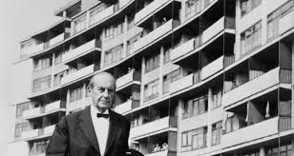
Walter Gropius

